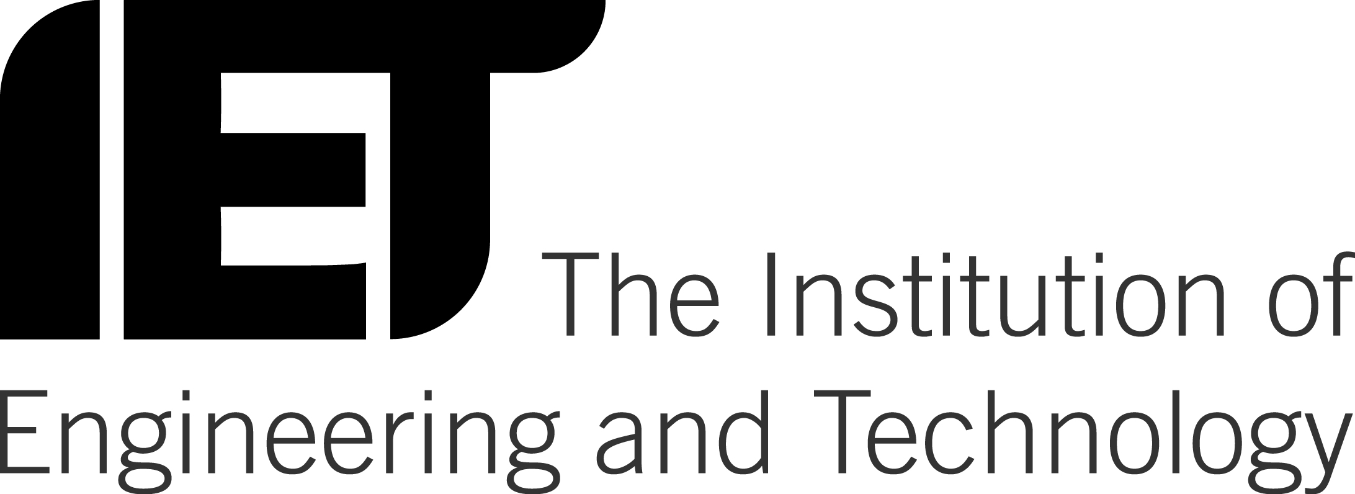
IET Licence to Publish Agreement
Paper Title (Work) | [insert title]
Course | Conference on Biomedical Image and Signal Processing （ICBISP）
Abstract No. or paper reference No. | [insert number] | Date of Event | 13 – 14 May 2017

1. The Author(s) hereby grant the IET and IAM a non-exclusive, worldwide, royalty-free, perpetual, transferable licence to use, distribute, display, make derivative works from, archive, copy and edit, in whole or in part, the Work, including all datasets and media objects included in the Work. The term "media objects" includes, but is not limited to: video files, image files, sounds files, and their constituent computer code. By signing this Agreement, the Author(s) hereby acknowledges and agrees to the publication of the Works in any form of media, whether or not these exist at the time of entering this Agreement.
2. The Author(s) warrants and represents that:
- Author(s) are the sole author(s) and sole holders of all legal and beneficial rights in and to the Work;
- The Work is an original work and has not been copied wholly or substantially from any other work or material or any other source;
- The Work qualifies for copyright protection under the Copyright, Designs and Patents Act 1988;
- The Work contains nothing libelous or contrary to law;
- Any scientific knowledge contained in the Work is true and accurate; and
- The Work (including media objects) contains no materials from other copyrighted or unpublished source that have been used without the written consent of the copyright owner(s).
3. The Author(s) grant the IET and IAM permission to use his/her name, and biography for the purpose of promoting the aforementioned Work, the presentation of the Work, or related IET/IAM activities.
4. The Author(s) warrants and represents that he/she has the authority to enter this license and release, and is authorised to act as agent for all listed authors for the purpose of submitting the Work to the IET.
5. The Author(s) shall retain copyright ownership of the Work. However, the Author(s) agree that the IET and IAM shall have the right to register copyright to a collective work (such as a conference technical digest) containing the Work. Such registration will not affect the copyright status of the individual articles, papers, or manuscripts contained in the collective work.
Crown copyright Authors: If the Author(s) were employees of the UK Government at the time the Work was prepared and the Work was prepared as part of their official government duties, the Submitting Author represents that the Work is not subject to Crown copyright protection. If the Work is Crown copyrighted material a Crown copyright form should be completed.
USA Government Employees Authors: If the Author(s) were employees of the United States Government at the time the Work was prepared and the Work was prepared as part of their official government duties, the Submitting Author represents that the Work is not subject to USA copyright protection. If the Work is USA Government copyrighted material a USA copyright form should be completed.
Note: If the Work was created in the course of the Author’s employment then it is owned by the Author’s employer, this form may need to be completed by a company representative. The Author(s) should refer to the employer’s company handbook and check the company policy.
This Agreement shall be governed by the laws of England and Wales and each party submits to the exclusive jurisdiction of the English Courts to settle any dispute or question relating to this Agreement.

With regard to the oral presentation at the conference/meeting:

Terms and conditions applicable to presentation

1. The Author(s) hereby grant IET permission to record any presentation of the Work at an IET meeting or conference (the “Presentation”), to use, distribute, archive, copy and edit the recording and accompanying Presentation, in whole or in part.

2. The Author(s) warrant and represent that they have have properly cited the source of all supporting material included in the Presentation. Furthermore, the use of supporting material from other sources is within the bounds of the generally accepted practice of the scientific and/or professional community.

______ Check here if you do not grant IET permission to record your Presentation. – N/A
The Author: [insert name & sign below]

Hereby agrees to all the above terms and conditions.

Date: [insert date]

